## VISVESVARAYA TECHNOLOGICAL UNIVERSITY

**Belagavi – 590 018**



A Mini Project Report On

## “COLLEGE EVENT MANAGEMENT SYSTEM”

Submitted in partial fulfilment of Bachelor of Engineering Degree

**In**

## ARTIFICIAL INTELLIGENCE AND MACHINE LEARNING ENGINEERING

V Semester

## 21CSL55–DBMS Laboratory and Mini Project Submitted by:

|  |  |
| --- | --- |
| **Syed Ismail Zabiulla** | **(1HK21AI059)** |
| **Mohammed Fatha P** | **(1HK21AI037)** |

Under the guidance of

**Prof. Shruthi Kulkarni**

**Department of Computer Science & Engineering**

**MARCH 2023-24**

**Department of Artificial Intelligence and Machine Learning Engineering**

**HKBK COLLEGE OF ENGINEERING**

**(Approved by AICTE & Affiliated to VTU)**

**Nagawara, Arabic College Post, Bangalore, Karnataka – 560045 Email:** [**info@hkbk.edu.in**](mailto:info@hkbk.edu.in) **URL:** **www,hkbk.edu.in**

# HKBK COLLEGE *of* ENGINEERING

Nagawara , Bangalore – 560045 Approved by AICTE & Affiliated to VTU

# Department of Artificial Intelligence and Machine Learning Engineering

Certificate

Certified that the Mini Project Work entitled “**COLLEGE EVENT MANAGEMENT SYSTEM”**, carried out by **Syed Ismail Zabiulla (1HK21AI059), Mohammed Fatha P(1HK21AI037),** are bonafide students of the **HKBK COLLEGE *of* ENGINEERING**, in partial fulfilment for the award of **Bachelor of Engineering** in **Artificial Intelligence and Machine Learning Engineering** of the **Visvesvaraya Technological University**, Belgaum, during the year **2024**. It is certified that all corrections/suggestion indicated for Internal Assessment have been incorporated in the report deposited in the departmental library. The project report has been approved as it satisfies the academic requirements in respect of **21CSL55 – DBMS Laboratory and Mini Project** prescribed for the said Degree.

Prof. Shruthi Kulkarni

Guide

Dr. Tabassum Ara

HOD

Dr. Mohammed Riyaz Ahmed Principal

Internal Examiners Signature with Date

External Examiners Signature with Date

# ACKNOWLEDGEMENT

We would like to place our regards and acknowledgement to all who helped in making this project possible. There are many people who worked behind the screen to help make it possible the below listed are a few of them.

First of all, we would take this opportunity to express our heartfelt gratitude to **Mr. C.M. Ibrahim, Chairman, Mr. C.M. Faiz Mohammed, Director** and **Dr. MD. Riyaz Ahmed,** Principal for all the infrastructure provided to complete the project in time.

We are deeply indebted to Dr. Tabassum Ara, HOD, Artificial intelligence and machine learning for the ineffable encouragement he provided in successful completion of the project. A special and earnest word of thanks to the AIML Project Coordinating Committee Member Prof. Shruthi Kulkarni for her constant support.

We sincerely thank our guide Prof. Shruthi Kulkarni, Assistant Professor for their constant assistance, support, patience, endurance and constructive suggestions for the betterment of the project.

We are extremely thankful to the teaching and non-teaching staff of the Department of Artificial Intelligence and Machine Learning for their valuable guidance and cooperation throughout our dissertation.

**Syed Ismail Zabiulla (1HK21AI059) Mohammed Fatha P (1HK21AI037)**

V

**CONTENTS**

|  |  |  |
| --- | --- | --- |
|  |  |  |
| **Chapter 1** | **Introduction** | **1** |
| **Chapter 2** | **ER Diagram** | **4** |
| **Chapter 3** | **System Analysis** | **5** |
| **Chapter 4** | **System Architecture** | **7** |
| **Chapter 5** | **Data Maintenance & Backup** | **10** |
| **Chapter 6**  **Chapter 7**  **Chapter 8** | **System Requirements Source Code**  **Snapshots** | **12**  **13**  **25** |

**List of Figures**

|  |  |  |
| --- | --- | --- |
|  |  |  |
| **1.0**  **1.1**  **1.2**  **1.3** | **Introduction**  **Abstract and Objectives**  **Scope**  **Features** | **1**  **2**  **2**  **3** |
| **2.0** | **ER Diagram** | **4** |
| **3.0** | **System Analysis** | **5** |
| **4.0** | **System Architecture** | **7** |
| **5.0** | **Data Maintenance & Backup** | **10** |
| **6.0**  **7.0**  **8.0** | **System Requirements**  **Source Code**  **Snapshots** | **12**  **13**  **25** |

# CHAPTER 1

## INTRODUCTION TO COLLEGE EVENT MANAGEMENT SYSTEM

This is a web-related application that grants us to move toward the whole information with respect to the college events according to departments. This general application made arrangements for helping the students of an association about details on the social exercises, specialized exercises, sports, courses, and workshops and so forth. It additionally permits the students to realize the forthcoming event details. The administrator would keep up the records of the students, readies the forthcoming event time table and transfer the present data with respect to the college events. The fundamental issue anticipated in the event particulars of interest are accounted for manually in distinct records, which is a difficult activity. Taking care of and updating records manually expands the opportunity of slip-ups. It requires some investment and necessities numerous workers to accomplish the task. It even needs security and incapacity to deliver different kinds of reports. So as to take care of these issues, another framework has been made, that endeavors to work the entire methodology considering the database integration approach

## ABSTRACT OF THE COLLEGE EVENT MANAGEMENT SYSTEM:

The College Event Management System is utilized to keep up college exercises details like social fest, specialized fest, college day festivities, workshops, project expo and courses and so forth. It gives data on events, keeps up students participation and it keeps up branch details sports details, and furthermore gives the college accomplishments. In the past framework, all the data needs to see in a hard document. Simultaneously while looking through any data it is too hard to even think about accessing and sets aside a great deal of effort to look through the specific information. Subsequently, so as to beat this issue an web application can be utilized to make this procedure simpler, secure and less blunder inclined. Increasingly effective data's will be accomplished through this framework.

## OBJECTIVES OF COLLEGE EVENT MANAGEMENT SYSTEM:

The main objective of the college event management system is to develop a system that correctly manages all the information related to numerous occasions that takes place in an institution. The purpose is to keep a centralized database of all occasion associated statistics. The goal is to assist numerous features and techniques essential control the information correctly.

## SCOPE OF COLLEGE EVENT MANGEMENT SYSTEM

The goal of this application is to develop a system that correctly manages all the information related to numerous occasions that takes place in an institution. The purpose is to keep a centralized database of all occasion associated statistics. The goal is to assist numerous features and techniques essential control the information correctly.

The Existing-system includes informing the students of the organization manually by going to their classes.

It also includes numerous paper works and cooperation many team members which may be hard to manage. Apart from these keeping track of events and registrations is also difficult. If there is even a slight mishap in managing these information’s it may result in bigger problems.

It is difficult to keep track of events happening in an organization, staying updated, allowed to give feedback and reading out reports of individual event is puzzling. Hence this Event Manager Web Application will allow us to manage all of this task in one central portal. This project is an Event management portal that is implemented on a website. This challenge offers characteristic of. remotely developing, removing, statistics retrieval, modifying of events and many different functions. This project is efficient in providing all the important access to both the system manager and admin and all the people related to a particular event. It gives organizer of the event access to see individuals and guest list. Also , one can be able to create or delete an event. The end user is able to view the created events and register for the same. The end user is able to view the created events and register for the same. This project will reduce paperwork and man power hence creating a hassle-free way of managing an event. Every event requirement will be traceable. One would be able to collect feedback from people and improve according to that feedback. It allows the organizer of the event to write a report after the completion of the event and also it allows the participants to view it.

The objective of this application is to develop a system that effectively managesall the data related to the various events that take place in an organization. The purpose isto maintain a centralized database of all related information. The goal is to support various functions and processes necessary to manage the data efficiently.

This project is an Event management portal that is implemented on a website.T his challenge offers characteristic of remotely developing, removing, statistics retrieval, modifying of events and

many different functions .This project is efficient in providing all the important access to both the system manager and admin and all the people related to a particular event.

## FEATURES OF THE COLLEGE EVENT MANAGEMENT SYSTEM:

1. Registration.
2. Login.
3. Add event details.
4. Update/ delete event details.
5. Add/ delete departments.
6. View/ search event details.
7. View/ search departments.
8. Generate event timetable.
9. Generate event performance graph.
10. View event timetable.
11. View event performance graph.
12. Logout.

# CHAPTER 2

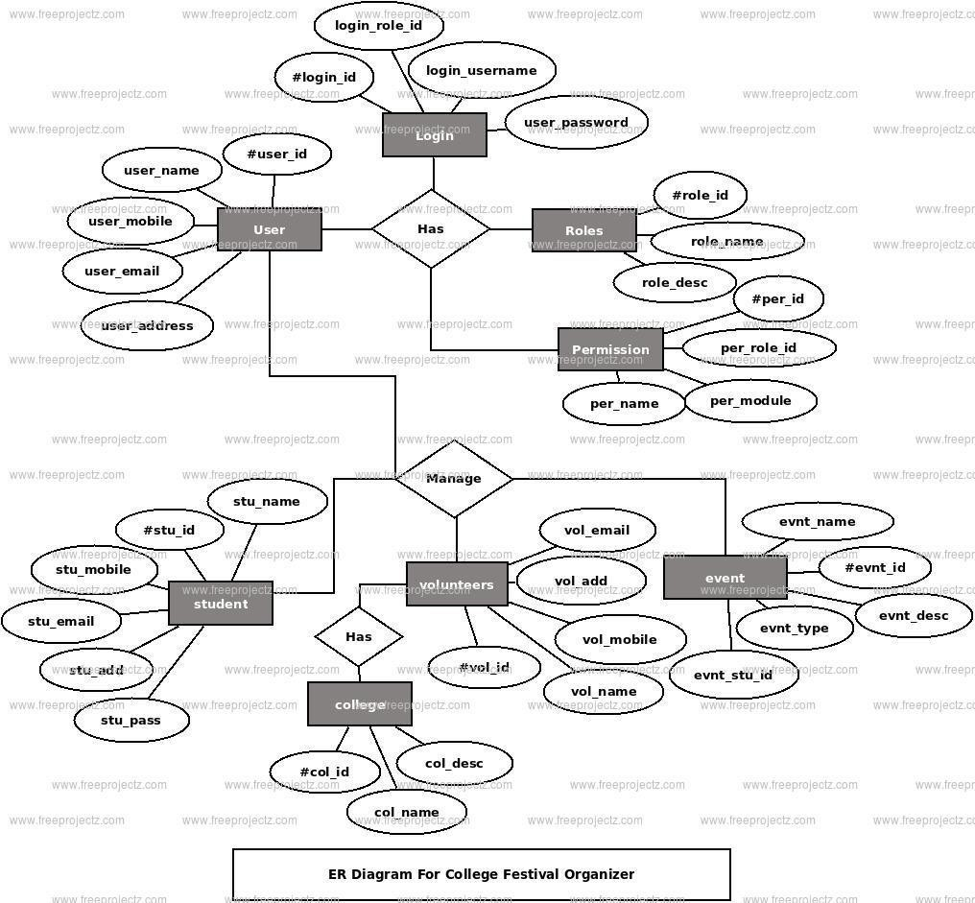**ER DIAGRAM:**

# CHAPTER 3

## SYSTEM ANALYSIS

System analysis is a process of gathering and interpreting facts, diagnosing problems and the information about the Student Fees Payment System to recommend improvements on the system. Itis a problem solving activity that requires intensive communication between the system users and system developers. System analysis or study is an important phase of any system development process. The system is studied to the minutest detail and analyzed. The system analyst plays the roleof the interrogator and dwells deep into the working of the present system. The system is viewed as awhole and the input to the system are identified. The outputs from the organizations are traced to thevarious processes. System analysis is concerned with becoming aware of the problem, identifying the relevant and decisional variables, analyzing and synthesizing the various factors and determiningan optimal or at least a satisfactory solution or program of action. A detailed study of the process must be made by various techniques like interviews, questionnaires etc. The data collected by these sources must be scrutinized to arrive to a conclusion. The conclusion is an understanding of how thesystem functions. This system is called the existing system. Now the existing system is subjected toclose study and problem areas are identified. The designer now functions as a problem solver and tries to sort out the difficulties that the enterprise faces. The solutions are given as proposals. The proposal is then weighed with the existing system analytically and the best one is selected. The proposal is presented to the user for an endorsement by the user. The proposal is reviewed on user request and suitable changes are made. This is loop that ends as soon as the user is satisfied with proposal. Preliminary study is the process of gathering and interpreting facts, using the informationfor further studies on the system. Preliminary study is problem solving activity that requires intensivecommunication between the system. users and system developers. It does various feasibility studies.In these studies a rough figure of the system activities can be obtained, from which the decision about the strategies to be followed for effective system study and analysis can be taken.

## Feasibility Study:

* + A feasibility study is a high-level capsule version of the entire System analysis andDesign

Process. The study begins by classifying the problem definition.

* + Feasibility is to determine if it’s worth doing. Once an acceptance problem definition has beengenerated, the analyst develops a logical model of the system.
  + A search for alternatives is analyzed carefully. There are 3 parts in feasibility study.

## :Operational Feasibility:

**Question that going to be asked are**

* + Will the system be used if it developed and implemented.
  + If there was sufficient support for the project from the management and from the users.
  + Have the users been involved in planning and development of the Project.

## Technical Feasibility:

* + Does the necessary technology exist to do what is been suggested.
  + Does the proposed equipment have the technical capacity for using the new system?
  + Are there technical guarantees of accuracy, reliability and data security?
  + The environment required in the development of system is any windows platform.
  + The observer pattern along with factory pattern will update the results eventually.

## Economical Feasibility:

* + To decide whether a project is economically feasible, to consider various factors as cost benefitanalysis, long-term returns and maintenance costs

# CHAPTER 4

## SYSTEM ARCHITECTURE OF COLLEGE EVENT MANAGEMENT SYSTEM

The system architecture of a School Fees Payment Management System typically involves several layers andcomponents working together to facilitate fee payment processes efficiently and securely. Here's a breakdownof the typical architecture.

## Presentation Layer:

* + This layer encompasses the user interface components that interact directly with users, includingstudents, parents, and administrative staff.
  + User interfaces may include web-based portals, mobile applications, or desktop applications.
  + Features may include account login, fee payment forms, fee statements, and reporting dashboards.

1. **Application Layer:**
   * The application layer contains the business logic and processing components responsible formanaging fee-related operations.
   * Key components include:
   * Fee Management Module: Manages fee structures, payment deadlines, fee categories, and feeadjustments (discounts, waivers).
   * Payment Processing Module: Handles payment transactions, payment gateway integration, andpayment verification.
   * Notification Module: Sends notifications to users about upcoming payment deadlines, paymentconfirmations, and overdue payments.
   * Reporting Module: Generates reports on fee collections, outstanding balances, and financialsummaries for administrators.

## Integration Layer:

This layer facilitates integration with external systems and services that are part of the fee payment process.Integration points may include:

* + Student Information System (SIS): Retrieves student information, enrollment status, and feedetails.
  + Accounting Software: Syncs fee-related transactions and financial data for accounting andreportingpurposes.
  + Payment Gateways: Interfaces with payment gateways to process online payments securely.
  + Messaging Services: Integrates with SMS or email services for sending notifications to user.

## Data Layer:

* + The data layer consists of the database and data storage components that store and managefee-relatedinformation.
  + Database Management System (DBMS): Stores data related to students, fees, payments,invoices, andtransaction logs.
  + Data Warehousing: Aggregates and stores historical fee data for reporting and analysis purposes.
  + File Storage: Stores supporting documents such as fee receipts, invoices, and financial reports.

## Security Layer:

* Security measures are implemented throughout the architecture to protectsensitive dataand ensurecompliance with privacy regulations.
* Authentication: Validates user identities through username/password authentication,multi-factorauthentication (MFA), or single sign-on (SSO).
* Authorization: Enforces access controls to restrict users' actions based on their roles andpermissions.
* Encryption: Encrypts data transmissions and storage to prevent unauthorized access ortampering.
* Audit Trails: Logs and monitors user activities for auditing and compliance purposes.

## Infrastructure Layer:

* This layer comprises the underlying hardware and network infrastructure needed tosupport thesystem's operation.
* Servers: Host the application components, databases, and other system resources.

## Networking Equipment:

* Provides network connectivity and ensures data communication between system components.
* Storage Devices: Store data files, database backups, and system logs.
* Cloud Services (optional): Utilizes cloud computing resources for scalability, redundancy, and disasterrecovery

# CHAPTER 5

## DATA MAINTENANCE AND BACKUP

Maintaining and backing up a college event management system is crucial for ensuring dataintegrityand system reliability. Here are some key steps:

## Regular Maintenance:

* + Conduct routine checks for system errors or glitches.
  + Update software and security patches regularly to prevent vulnerabilities.
  + Monitor system performance to ensure optimal functionality.
  + Address any user feedback or reported issues promptly.

## Data Backups:

* + Implement automated daily or weekly backups of the entire system and database.
  + Store backups securely on-site and off-site to prevent data loss in case of hardware failure,theft, or natural disasters.
  + Test the backup restoration process periodically to verify data integrity and system recovery capability.
  + Keep multiple backup copies, including historical data, to facilitate rollback in case of error or data corruption.

## Security Measures:

* + Implement access controls and user authentication mechanisms to prevent unauthorizedaccess tosensitive data.
  + Encrypt sensitive information to protect against data breaches or theft.
  + Regularly review and update security policies to adapt to evolving threats andcompliancerequirements.
  + Conduct security audits and penetration testing to identify and address vulnerabilitiesproactively.

## Disaster Recovery Plan:

* + Develop a comprehensive disaster recovery plan outlining procedures for system restoration in case ofcatastrophic events.
  + Identify key personnel responsible for executing the disaster recovery plan and ensure they areadequately trained.
  + Conduct regular drills or simulations to test the effectiveness of the disaster recovery plan and refineit as needed.

## Documentation and Training:

* + Maintain detailed documentation of the system architecture, configurations, and maintenanceprocedures.
  + Provide regular training sessions for system administrators and users to ensure they are familiar withbest practices and protocols.
  + By following these steps, you can ensure the reliability, security, and longevity of your school feespayment management system

# CHAPTER 6

**SYSTEM REQUIREMENTS**

## Software Requirements:

**Front End**: HTML, AJAX, JQUERY, JAVASCRIPT

1. **HTML:** HTML (Hypertext Markup Language) is the code that is used to structure a web page and its content. For example, content could be structured within a set of paragraphs, a list of bulletedpoints, or usingimages and data tables.
2. **AJAX:** AJAX is a technique for creating fast and dynamic web pages. AJAX allows web pagesto be updated asynchronously by exchanging small amounts of data with the server behind the scenes.
3. **JQUERY**: jQuery takes a lot of common tasks that require many lines of JavaScript code to accomplish,and wraps them into methods that you can call with a single line of code.
4. **JAVASCRIPT:** JavaScript is a scripting language that enables you to create dynamically updating content, control multimedia, animate images etc.

## Back End: PHP, MySQL

1. **PHP:** PHP (short for Hypertext Preprocessor) is the most widely used open source and generalpurpose server-side scripting language used mainly in web development to create dynamic websites and applications.
2. **MySQL:** MySQL creates a database for storing, querying, updating and managing data.
3. XAMPP Server

## Hardware Requirements :

* + SYSTEM: Quad core system
  + RAM: 8 GB
  + PROCESSOR: Intel® Core™ i5/ AMD Ryzen 5 or above
  + HARD DISK: up to 8GB of available space may be required. However, 50 MB free space isrequiredin boot drive even if you are installing in other drive

# CHAPTER 7

**SOURCE CODE**

## LOGIN PAGE:

-- phpMyAdmin SQL Dump

-- version 4.9.0.1

-- https:/[/www.phpmyadmin.net/](http://www.phpmyadmin.net/)

--

-- Host: 127.0.0.1

-- Generation Time: Nov 12, 2019 at 03:57 AM

-- Server version: 10.4.6-MariaDB

-- PHP Version: 7.3.9

SET SQL_MODE = "NO_AUTO_VALUE_ON_ZERO"; SET AUTOCOMMIT = 0;

START TRANSACTION;

SET time_zone = "+00:00";

/*!40101 SET @OLD_CHARACTER_SET_CLIENT=@@CHARACTER_SET_CLIENT */;

/*!40101 SET @OLD_CHARACTER_SET_RESULTS=@@CHARACTER_SET_RESULTS */;

/*!40101 SET @OLD_COLLATION_CONNECTION=@@COLLATION_CONNECTION */;

/*!40101 SET NAMES utf8mb4 */;

--

-- Database: `cems`

--

--

-- Table structure for table `events`

--

CREATE TABLE `events` (

`event_id` int(11) NOT NULL,

`event_title` varchar(50) NOT NULL,

`event_price` int(11) DEFAULT NULL,

`participents` int(100) DEFAULT 0,

`img_link` text DEFAULT NULL,

`type_id` int(11) DEFAULT NULL

) ENGINE=InnoDB DEFAULT CHARSET=latin1;

--

-- Dumping data for table `events`

--

INSERT INTO `events` (`event_id`, `event_title`, `event_price`, `participents`, `img_link`, `type_id`) VALUES

(1, 'Cryptohunt', 100, 0, 'images/crypto.png', 1),

(2, 'Search-it', 50, 2, 'images/cs03.jpg', 1),

(3, 'Technical-Quiz', 50, 2, 'images/quiz.png', 1),

(4, 'Competitive-Coding', 50, 1, 'images/coding.jpg', 1),

(5, 'Pubg', 50, 1, 'images/pubg.jpg', 2),

(6, 'Counter-Strike', 100, 1, 'images/counter.jpg\r\n', 2),

(7, 'Fashion-Show', 200, 1, 'images/onstage.jpg', 3),

(8, 'Dance', 100, 0, 'images/dance.jpg', 3),

(9, 'Singing', 50, 0, 'images/sing.jpg', 3),

(10, 'Svit-Idol', 100, 0, 'images/idol.jpg', 3),

(11, 'Cooking-Without-Fire', 50, 0, 'images/cook.jpg', 4),

(12, 'Short-Movie', 200, 0, 'images/offstage.jpg', 4),

(13, 'Mehandi', 100, 0, 'image/mehandi.jpg', 4),

(14, 'Rangoli', 50, 0, 'images/cs03.jpg', 4);

--

-- Table structure for table `event_info`

--

CREATE TABLE `event_info` (

`event_id` int(10) NOT NULL,

`Date` date DEFAULT NULL,

`time` varchar(20) NOT NULL,

`location` varchar(300) NOT NULL

) ENGINE=InnoDB DEFAULT CHARSET=latin1;

--

-- Dumping data for table `event_info`

--

INSERT INTO `event_info` (`event_id`, `Date`, `time`, `location`) VALUES (1, '2022-11-16', '3.00pm', '135 Room'),

(2, '2022-11-16', '1.00pm', '020 Lab'),

(3, '2022-11-16', '11.00am', '136 Room'),

(4, '2022-11-16', '9.30am', '020 Lab'),

(5, '2022-10-17', '10.00am', '121 Lab'),

(6, '2022-10-17', '11.00am', '122 Lab'),

(7, '2022-10-17', '9.30pm', 'ON Stage'),

(8, '2022-10-17', '7.00pm', 'ON Stage'),

(9, '2022-10-17', '5.00pm', 'ON Stage'),

(10, '2022-10-17', '6.00pm', 'ON Stage'),

(11, '2022-10-16', '10.30am', '123 Room'),

(12, '2022-10-16', '10.00am', '021 Lab'),

(13, '2022-11-12', '3pm', '021 lab'),

(14, '2022-11-13', '2.00pm', 'Quandrangle');

--

-- Table structure for table `event_type`

--

CREATE TABLE `event_type` (

`type_id` int(10) NOT NULL,

`type_title` text NOT NULL

) ENGINE=InnoDB DEFAULT CHARSET=latin1;

--

-- Dumping data for table `event_type`

--

INSERT INTO `event_type` (`type_id`, `type_title`) VALUES (1, 'Technical Events'),

(2, 'Gaming Events'), (3, 'On Stage Events'), (4, 'Off Stage Events');

--

-- Table structure for table `participent`

--

CREATE TABLE `participent` (

`usn` varchar(20) NOT NULL,

`name` varchar(100) NOT NULL,

`branch` varchar(11) NOT NULL,

`sem` int(11) NOT NULL,

`email` varchar(300) NOT NULL,

`phone` varchar(12) NOT NULL,

`college` varchar(20) NOT NULL

) ENGINE=InnoDB DEFAULT CHARSET=latin1;

--

-- Dumping data for table `participent`

--

INSERT INTO `participent` (`usn`, `name`, `br anch`, `sem`, `email`, `phone`, `college`) VALUES

('1VA17CS005', 'Anu', 'AI&ML', 5, 'annapoornaba@gmail.com', '8123300011', 'svit'),

('1VA17CS012', 'BHAVANA', 'ai&ml', 5, 'BH AVANA@GMAIL.COM', '9934736623', 'Svit'),

('1VA17CS022', 'Kavya', 'ai&ml', 5, 'Kavya@gmail.com', '7888387323', 'svit'),

('1 VA17CS025', 'Mythri', 'ISE', 5, 'mythri@saividya.ac.in', '8998848488', 'svit'),

('1VA17CS034', 'Prajwal', 'ai&ml', 5, 'prajwal@gmail.com', '9858787438', 'svit'), ('1VA17IS045', 'Prathiksha', 'ISE', 5, 'prathi@gmail.com', '7897854345', 'svit');

--

-- Table structure for table `registered`

--

CREATE TABLE `registered` (

`rid` int(11) NOT NULL,

`usn` varchar(20) DEFAULT NULL,

`event_id` int(11) DEFAULT NULL

) ENGINE=InnoDB DEFAULT CHARSET=latin1;

--

-- Dumping data for table `registered`

--

INSERT INTO `registered` (`rid`, `usn`, `event_id`) VALUES (1, '1VA17CS005', 2),

(2, '1VA17CS012', 4),

(3, '1VA17CS034', 2),

(4, '1VA17CS005', 3),

(5, '1VA17CS012', 3),

(6, '1VA17CS012', 5),

(8, '1VA17CS005', 6),

(10, '1VA17CS034', 7);

--

-- Triggers `registered`

--

DELIMITER $$

CREATE TRIGGER `count` AFTER INSERT ON `registered` FOR EACH ROW update events set events.participents=events.participents+1

WHERE events.event_id=new.event_id

$$ DELIMITER

-- Table structure for table `staff_coordinator`

CREATE TABLE `staff_coordinator` (

`stid` int(11) NOT NULL,

`name` varchar(100) NOT NULL,

`phone` varchar(10) DEFAULT NULL,

`event_id` int(11) DEFAULT NULL

) ENGINE=InnoDB DEFAULT CHARSET=latin1;

--

-- Dumping data for table `staff_coordinator`

--

INSERT INTO `staff_coordinator` (`stid`, `name`, `phone`, `event_id`) VALUES (1, 'Mamatha.s', '9956436610', 1),

(2, 'Mamatha', '9956436123', 2),

(3, 'Suparna.A', '9956436456', 3),

(4, 'Geetha', '9956436789', 4),

(5, 'Radha', '9956436101', 5),

(6, 'Usha.D.R', '9123436610', 6),

(7, 'Deeksha.G', '9456436610', 7),

(8, 'Deeksha.Patgar', '9789436610', 8),

(9, 'Shubha Naik', '9956412310', 9),

(10 , 'Sairaj Patgar', '9956445610', 10),

(11, 'Reshma Hittalmakhi', '9956473510', 11),

(12, 'Annanya.A.G', '9955636610', 12),

(13, 'Sushma', '8948476464', 13),

(14, 'Bhavya', '9876543210', 14);

--

-- Table structure for table `student_coordinator`

--

CREATE TABLE `student_coordinator` (

`sid` int(11) NOT NULL,

`st_name` varchar(100) NOT NULL,

`phone` varchar(10) DEFAULT NULL,

`event_id` int(11) DEFAULT NULL

) ENGINE=InnoDB DEFAULT CHARSET=latin1;

--

-- Dumping data for table `student_coordinator`

--

INSERT INTO `student_coordinator` (`sid`, `st_name`, `phone`, `event_id`) VALUES (1, 'Prajwal Srinivas', '6956436610', 1),

(2, 'Rakesh Mariyappa', '7956436123', 2),

(3, 'Arjun.A', '8956436456', 3),

(4, 'Sanjana', '6956436789', 4),

(5, 'NIkhil Bhat', '7956436101', 5),

(6, 'Pruthvi P', '8123436610', 6),

(7, 'Anshuman.A.N', '6456436610', 7),

(8, 'Abhinandhan.A', '7789436610', 8),

(9, 'Suraj Upadhya', '7956412310', 9),

(10, 'Imran Khalil Khan', '7956445610', 10),

(11, 'Mythri', '6956473510', 11),

(12, 'Pratyush Mishra', '8955636610', 12),

(13, 'Kavya', '8994874384', 13),

(14, 'Rishitha', NULL, 14);

--

-- Indexes for dumped tables

--

--

-- Indexes for table `events`

--

ALTER TABLE `events`

ADD PRIMARY KEY (`event_id`);

--

-- Indexes for table `event_info`

--

ALTER TABLE `event_info`

ADD PRIMARY KEY (`event_id`);

-- Indexes for table `event_type`

--

ALTER TABLE `event_type` ADD PRIMARY KEY (`type_id`);

--

-- Indexes for table `participent`

--

ALTER TABLE `participent` ADD PRIMARY KEY (`usn`);

--

-- Indexes for table `registered`

--

ALTER TABLE `registered` ADD PRIMARY KEY (`rid`);

--

-- Indexes for table `staff_coordinator`

--

ALTER TABLE `staff_coordinator` ADD PRIMARY KEY (`stid`);

--

-- Indexes for table `student_coordinator`

--

ALTER TABLE `student_coordinator` ADD PRIMARY KEY (`sid`);

-- AUTO_INCREMENT for dumped tables

-- AUTO_INCREMENT for table `event_info`

--

ALTER TABLE `event_info`

MODIFY `event_id` int(10) NOT NULL AUTO_INCREMENT, AUTO_INCREMENT=15;

--

-- AUTO_INCREMENT for table `registered`

--

ALTER TABLE `registered`

MODIFY `rid` int(11) NOT NULL AUTO_INCREMENT, AUTO_INCREMENT=11;

--

-- AUTO_INCREMENT for table `staff_coordinator`

--

ALTER TABLE `staff_coordinator`

MODIFY `stid` int(11) NOT NULL AUTO_INCREMENT, AUTO_INCREMENT=15;

--

-- AUTO_INCREMENT for table `student_coordinator`

ALTER TABLE `student_coordinator`

MODIFY `sid` int(11) NOT NULL AUTO_INCREMENT, AUTO_INCREMENT=15; COMMIT;

# CHAPTER 8

## SNAPSHOTS

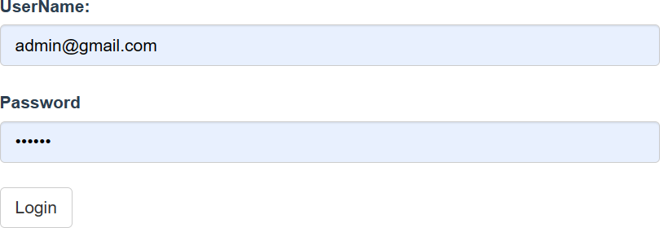

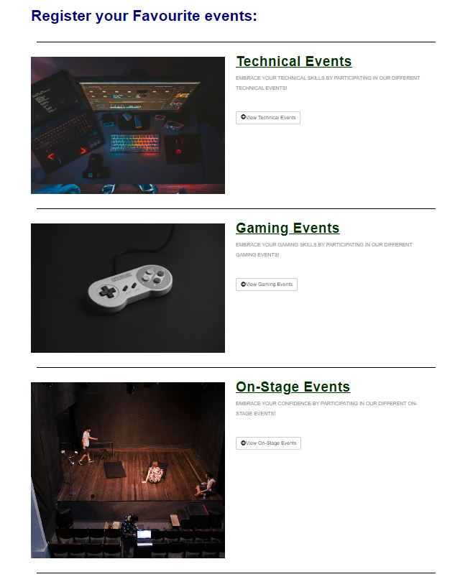**Fig:7.1Loginpage**

**Fig:7.2**

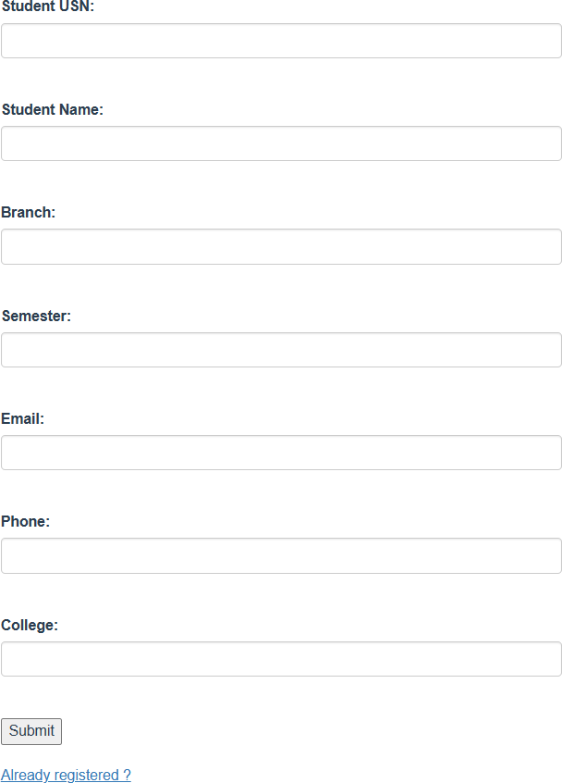 **Dashboard**

**Fig:7.3**

**Student Registratio**

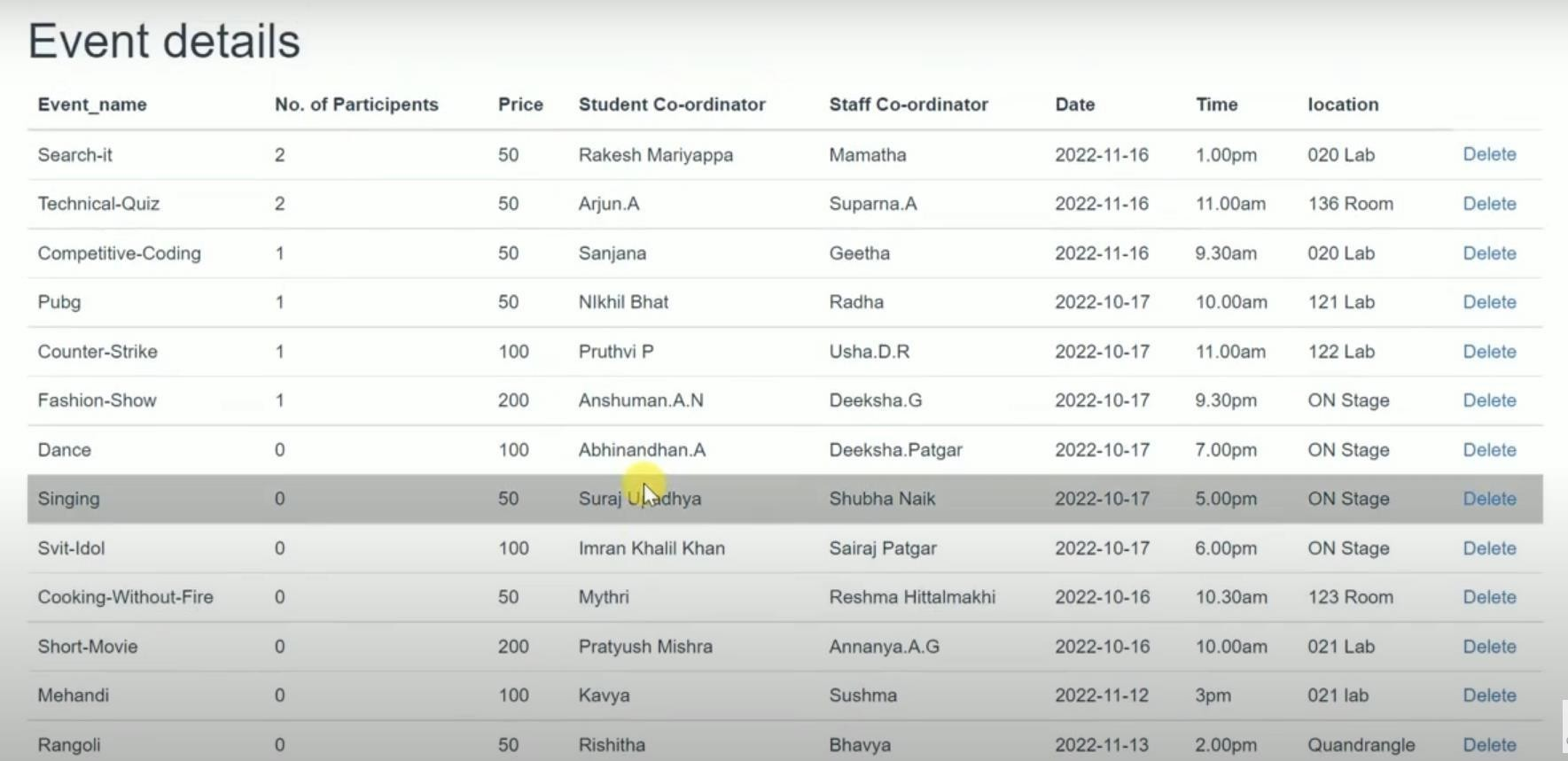

**Fig:7.5 Stude**

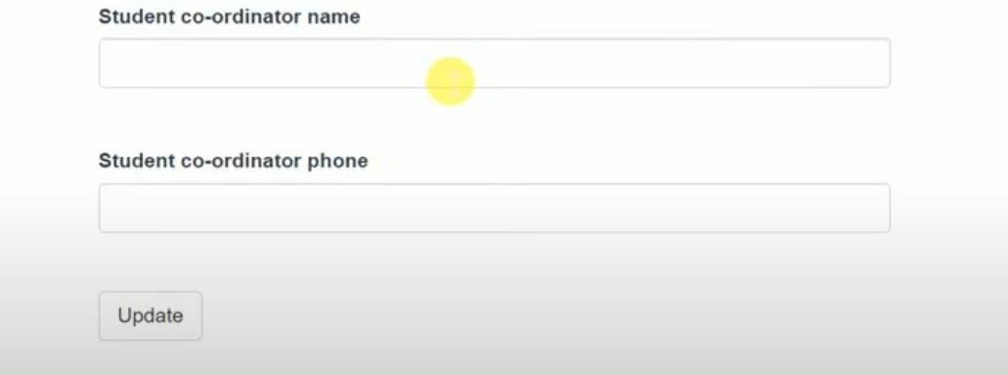

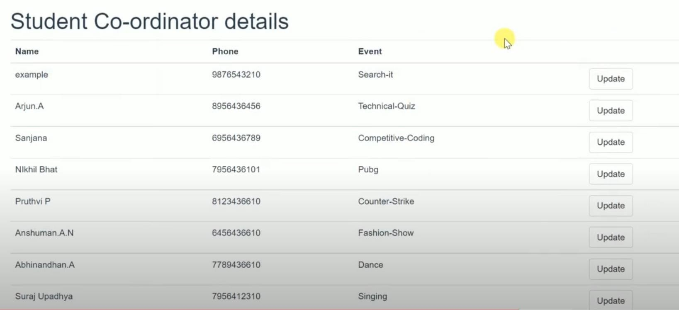

# CONCLUSION:

In this way the College Event Management System is useful for establishment to keep up

the event records of students. This lessens the burden of client and it is additionally an effi-

cient procedure. The data can be effortlessly retrieved. The framework keeps up all records

easily. The proposed framework is automated and has been created utilizing advance lang-

uage in this way it gives a greater number of facilities than present framework. It gives

fast access to any information.

In conclusion, effective management of college event is crucial for ensuring the smooth operation of educational institutions and the attainment of educational goals. By implementing transparent, fair, and efficient fee management systems, schools can enhance parent satisfaction, improve financial stability, and ultimately provide better educational experiences for students. Utilizing technology such as event management software can streamline processes, reduce errors, and increase accountability. Additionally, offering flexible payment options and financial assistance programs can help alleviate financial burdens on families and ensure access to education for all students. Clear communication and collaboration between school administrators, parents, and students are essential for addressing concerns and resolving issues related to school fees. Ultimately, prioritizing the effective management of school fees contributes to the overall success and sustainability of educational institutions, enabling them to fulfill their mission of providing quality education to future generations. By continuously evaluating and refining fee management strategies, schools can adapt to changing needs and challenges, ensuring their long-term viability and success in servingtheir communities.

In conclusion, effective management of Student Council fees payment is paramount for ensuring transparency, accountability, and the smooth functioning of student organizations. A well-organized system facilitates the collection of dues, allocation of funds for various activities and initiatives, and fosters trust among students regarding the utilization of their contributions. It is imperative for the Student Council to implement efficient payment mechanisms, such as online portals or designated collection points, to streamline the process and enhance convenience for students. Additionally, maintaining transparent financialrecords and providing regular updates on expenditure promotes accountability and enables students to actively participate in decision-making processes. Ultimately, by prioritizing effective management practices, the Student Council can maximize the impact of fee payments, enriching the overall student experience and fostering a vibrant campus community.

# REFERENCES:

1. https://[www.javatpoint.com/java-tutorial](http://www.javatpoint.com/java-tutorial) --This link is referred for java tutorial.
2. https://[www.geeksforgeeks.org/html-tutorial/](http://www.geeksforgeeks.org/html-tutorial/) --This link is referred for HTML tutorial.
3. https://[www.geeksforgeeks.org/css-tutorial/](http://www.geeksforgeeks.org/css-tutorial/) --This link is referred for CSS .
4. https://[www.geeksforgeeks.org/php-tutorial/](http://www.geeksforgeeks.org/php-tutorial/) --This link is referred for PHP tutorial.
5. FUNDAMENTALS OF DATABASE MANAGEMENT SYSTEM—This Textbook is referred for DBMS.
6. XAMPP INSTALLATION -- https://[www.apachefreinds.org/download.html.](http://www.apachefreinds.org/download.html)